|  |
| --- |
|  |
| User Manual |
|  |
| Clinical Support System |

**BIOCORE LAB UTEM**

December 3, 2015

Authored by: Amalina

User Manual

Clinical Support System

Table of Contents

Login 2

Forgot Password 3

Logout 4

Change Account 5

Main Menu 8

Patient Management System 9

Patient Consultation 15

Pharmacy Info System 19

Table of Figure

Figure 1 3

Figure 2 4

Figure 3 5

Figure 4 6

Figure 5 6

Figure 6 7

Figure 7 7

Figure 8 8

Figure 9 9

Figure 10 10

Figure 11 10

Figure 12 11

Figure 13 11

Figure 14 12

Figure 15 12

Figure 16 13

Figure 17 13

Figure 18 14

Figure 19 14

Figure 20 15

Figure 21 16

Figure 22 16

Figure 23 17

Figure 24 18

Figure 25 19

Figure 26 20

Figure 27 20

Figure 28 21

Figure 29 21

Figure 30 22

Figure 31 22

Figure 32 23

Figure 33 24

Figure 34 25

Figure 35 25

Figure 36 26

Figure 37 27

Figure 38 28

Figure 39 28

Figure 40 29

# Login

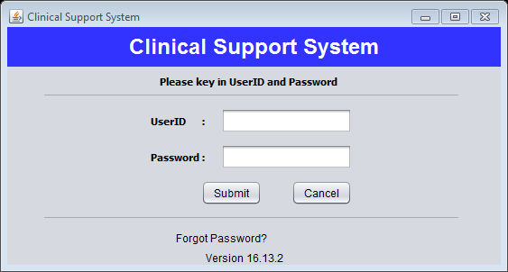

**2**

**1**

Figure 1

**Step 1:** Fill in the text fields with details needed.

**Step 2:** Click “Submit” button.

# Forgot Password

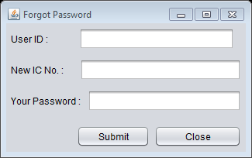

**2**

**1**

Figure 2

**Step 1:** Fill in the text fields with details needed.

**Step 2:** Click “Submit” button.

# Logout

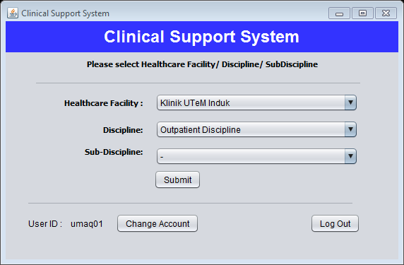

**1**

Figure 3

**Step 1:** Click “Log Out” button.

# Change Account



**1**

Figure 4

**Step 1:** Click “Change Account” button. User profile will be display.

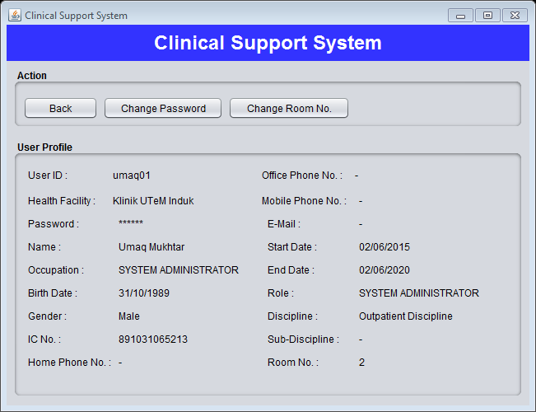

**2**

Figure 5

**Step 2:** To change user password click “Change Password” button. Figure below will be display.

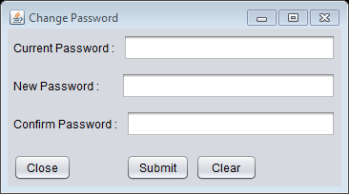

**5**

**4**

**3**

Figure 6

**Step 3:** Fill the text fields.

**Step 4:** Click “Submit” button to submit.

**Step 5:** Click “Close” button to close the menu.



**6**

Figure 7

**Step 6:** Click “Change Room No.” button to change user room number. Then figure below will be display.

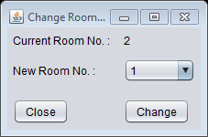

**9**

**8**

**7**

Figure 8

**Step 7:** Select new room number.

**Step 8:** Click “Change” button to save.

**Step 9:** Click “Close” button to close the menu.

# Main Menu



**2**

**1**

Figure 9

**Step 1:** Select the item.

**Step 2:** Click “Submit” button to go to the main menu page.

# Patient Management System

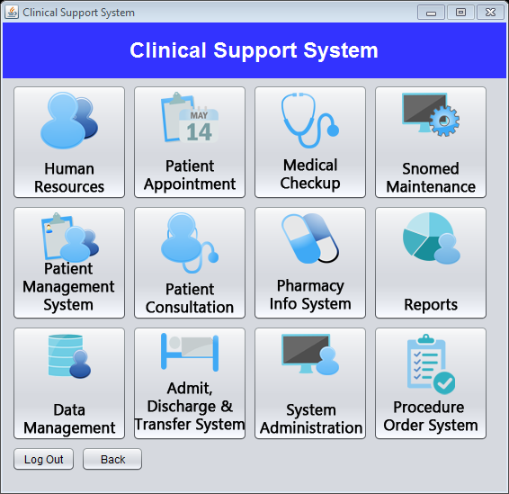

**1**

Figure 10

**Step 1:** Click “Patient Management System” button.

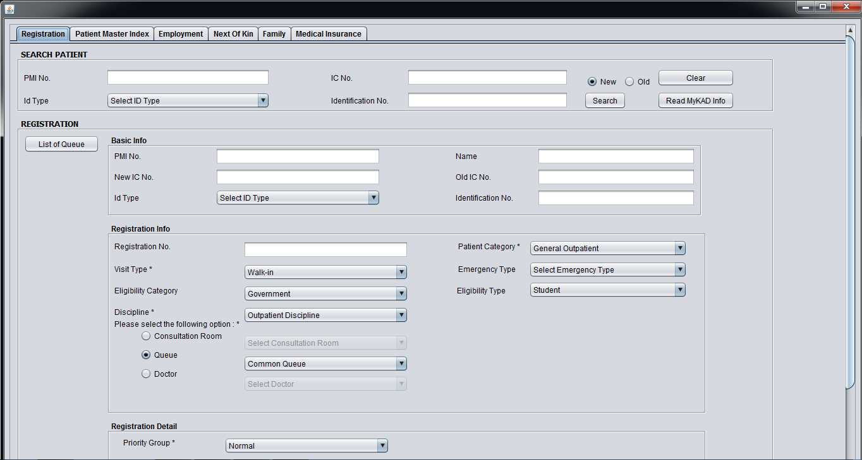

**7**

**5**

**4**

**3**

**2**

Figure 11

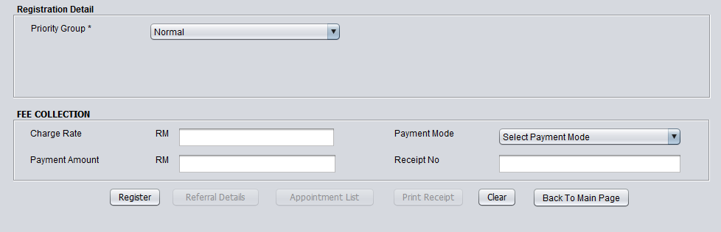

**6**

**5**

Figure 12

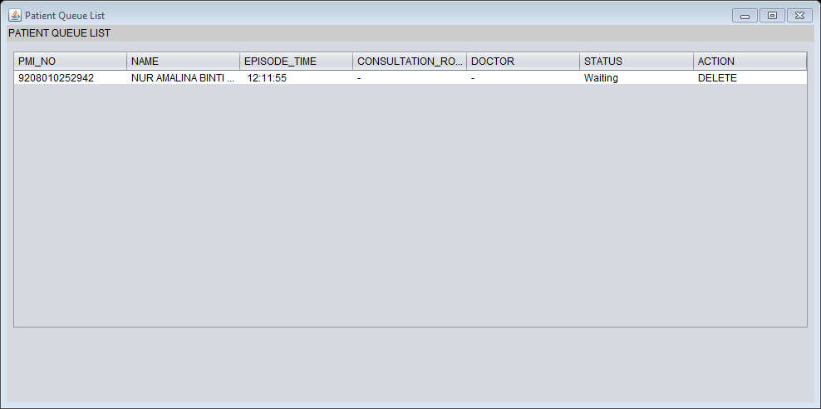

Figure 13

**Step 2:** Click “Registration” menu bar to do the patient registration.

**Step 3:** Fill in the text fields with details needed.

**Step 4:** Click “Search” button to search patient details.

**Step 5:** Fill in the text fields with details needed.

**Step 6:** Click “Register” button to register patient.

**Step 7:** Click “List of Queue” button to the patient in register list.

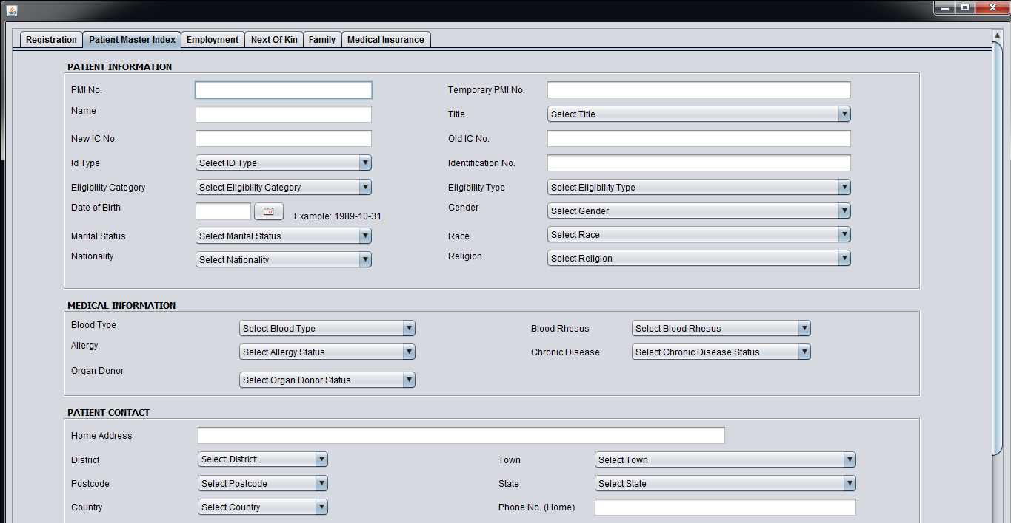

**8**

**9**

Figure 14

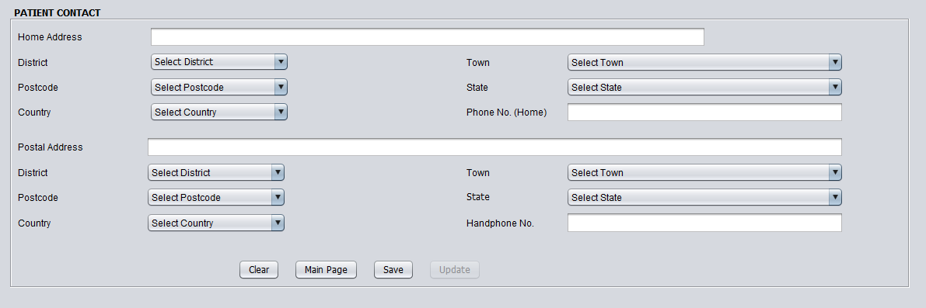

**10**

Figure 15

**Step 8:** Click “Patient Master Index” menu bar.

**Step 9:** Fill in the text fields with details needed.

**Step 10:** Click “Save” button to save patient details.

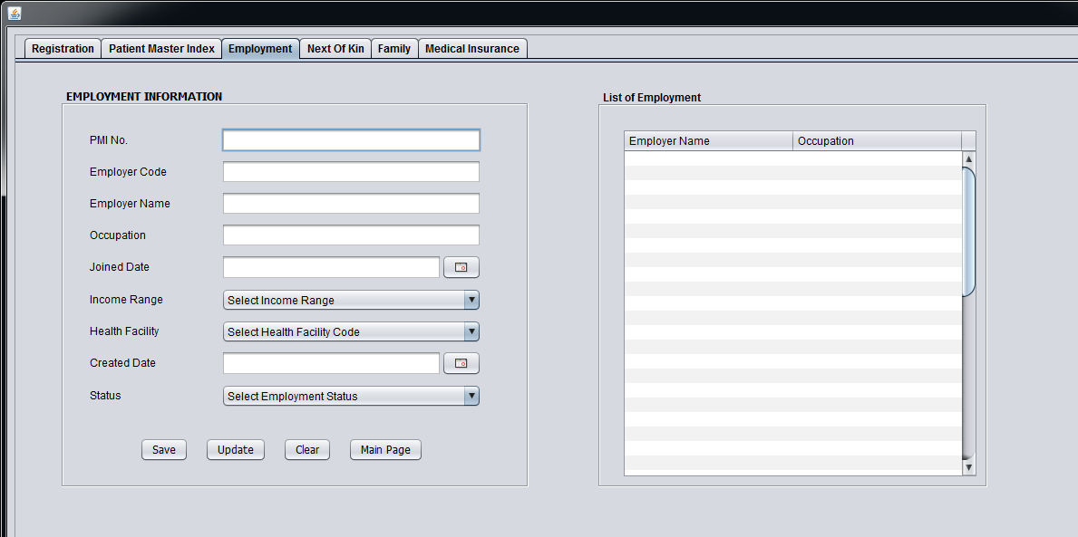

**13**

**12**

**11**

Figure 16

**Step 8:** Click “Employment” menu bar.

**Step 9:** Fill in the text fields with details needed.

**Step 10:** Click “Save” button to save patient details.

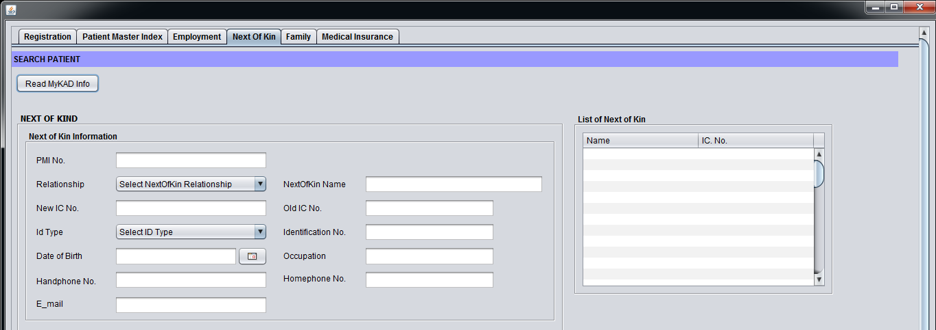

**15**

**14**

Figure 17

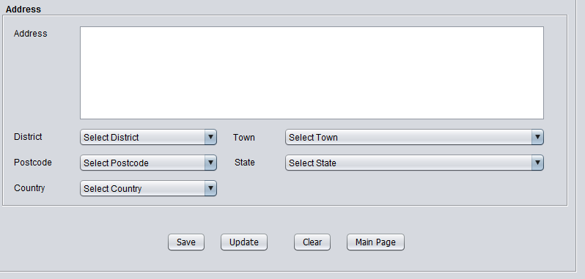

**16**

**17**

Figure 18

**Step 14:** Click “Next of Kin” menu bar.

**Step 15:** Fill in the text fields with details needed.

**Step 16:** Fill in the text fields with details needed.

**Step 17:** Click “Save” button to save patient details.

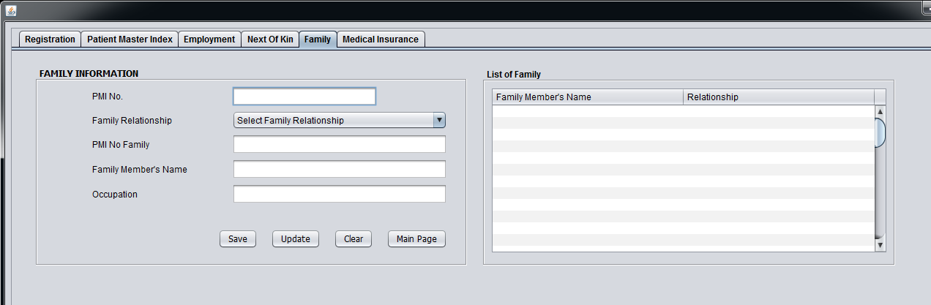

**19**

**18**

**20**

Figure 19

**Step 18:** Click “Family” menu bar.

**Step 19:** Fill in the text fields with details needed.

**Step 20:** Click “Save” button to save patient details.

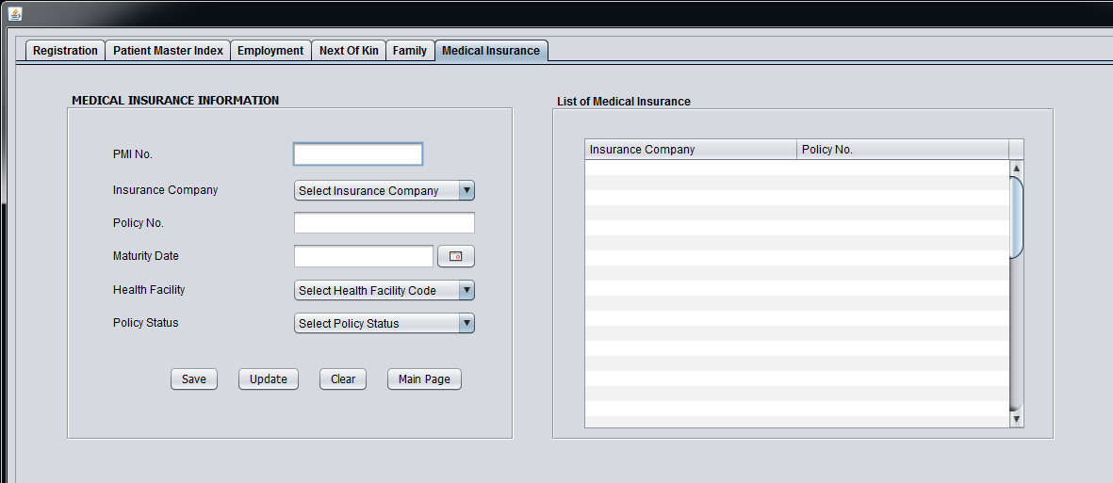

**23**

**22**

**21**

Figure 20

**Step 14:** Click “Medical Insurance” menu bar.

**Step 15:** Fill in the text fields with details needed.

**Step 17:** Click “Save” button to save patient details.

# Patient Consultation



**1**

Figure 21

**Step 1:** Click “Patient Consultation” button.

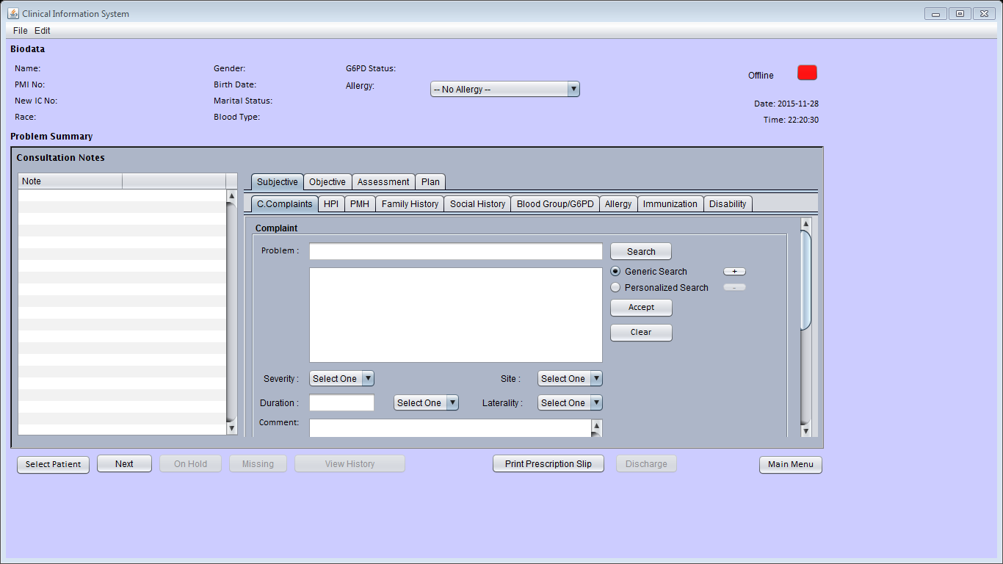

**3**

**2**

Figure 22

**Step 2:** Click “Select Patient” button to select patient in list.

**Step 3:** Click “Next” button for next patient.

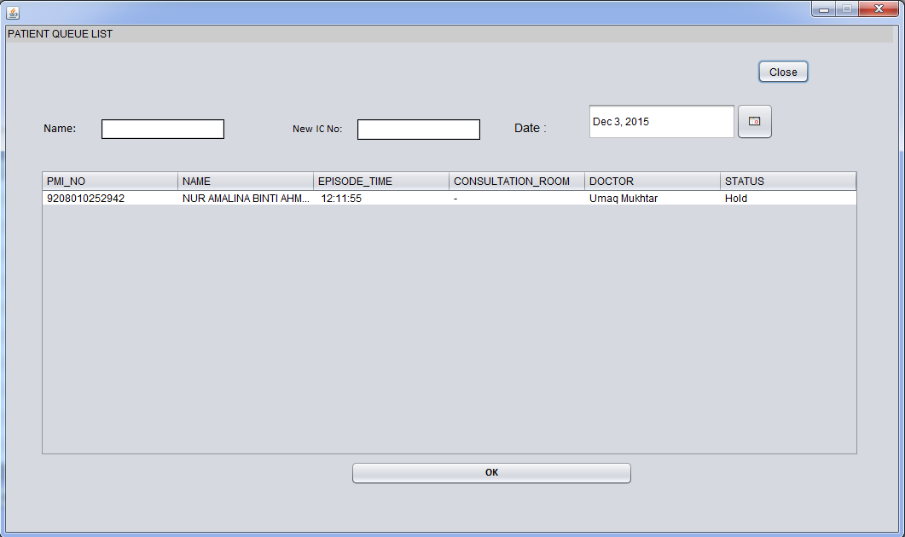

**7**

**6**

**4**

**5**

Figure 23

**Step 4:** Fill the details for specific details.

**Step 5:** Click patient details to select patient.

**Step 6:** Click “OK” button to select patient in list.

**Step 7:** Click “Close” button.

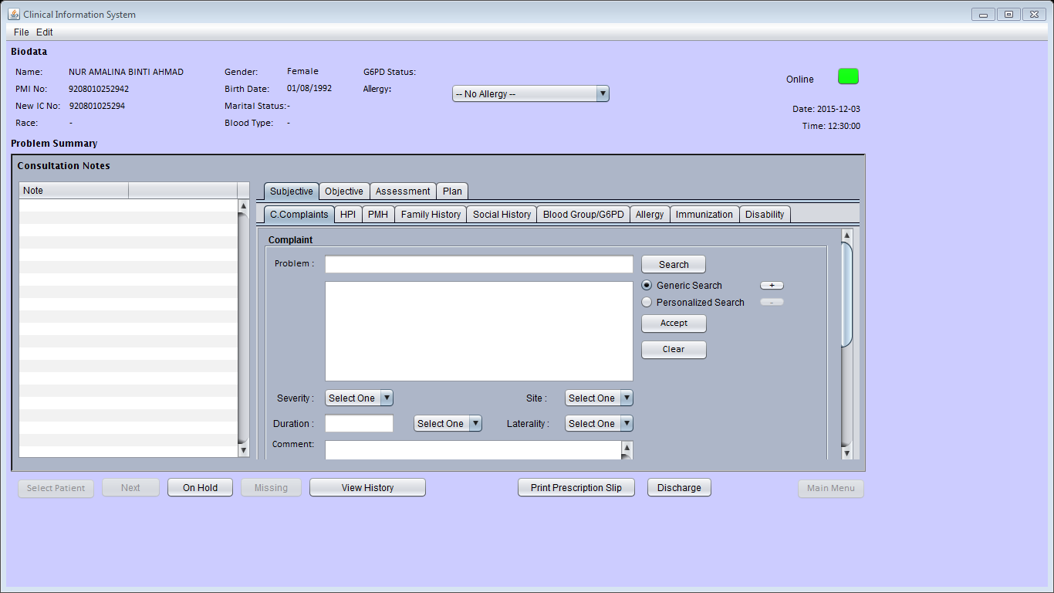

**12**

**11**

**9**

**10**

**8**

Figure 24

**Step 8:** Fill the details for specific details.

**Step 9**: Click “View History” button to view details patient.

**Step 10:** Click “On Hold” button to hold patient.

**Step 11:** Click “Print Prescription Slip” button to print drug order.

**Step 12:** Click “Discharge” button to end session.

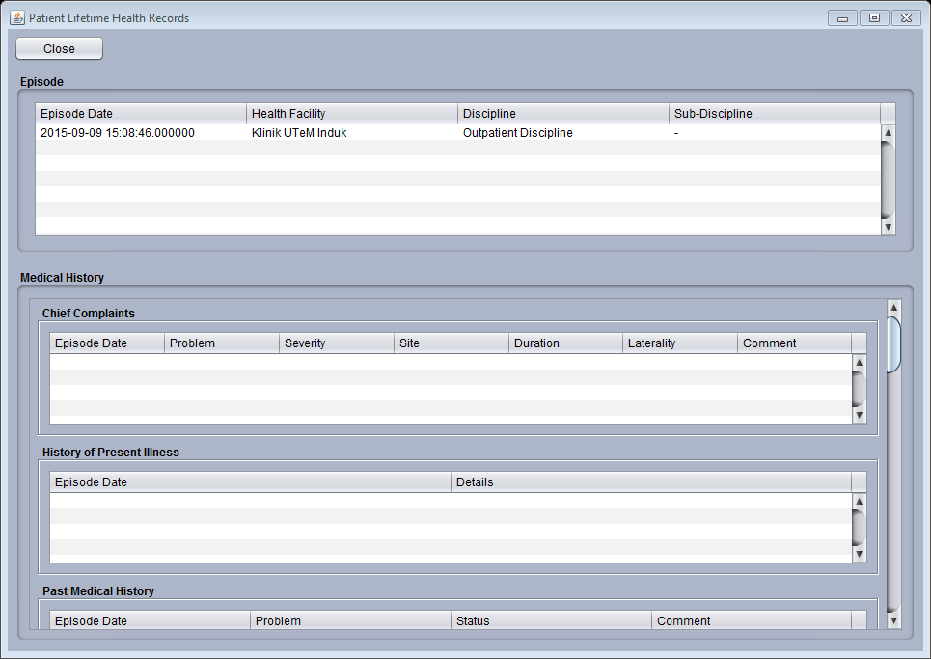

Figure 25

# Pharmacy Info System



**1**

Figure 26

**Step 1:** Click “Pharmacy Info System” button.

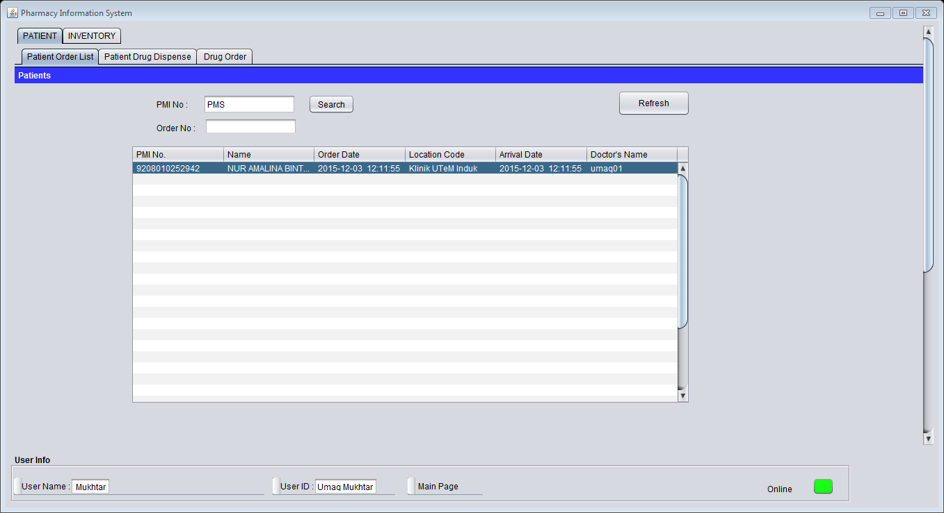

**4**

**3**

**2**

Figure 27

**Step 2:** Click “Patient Order List” menu bar to select patient.

**Step 3:** Double click at patient name.

**Step 4:** Click “Main Page” button to back to main menu.

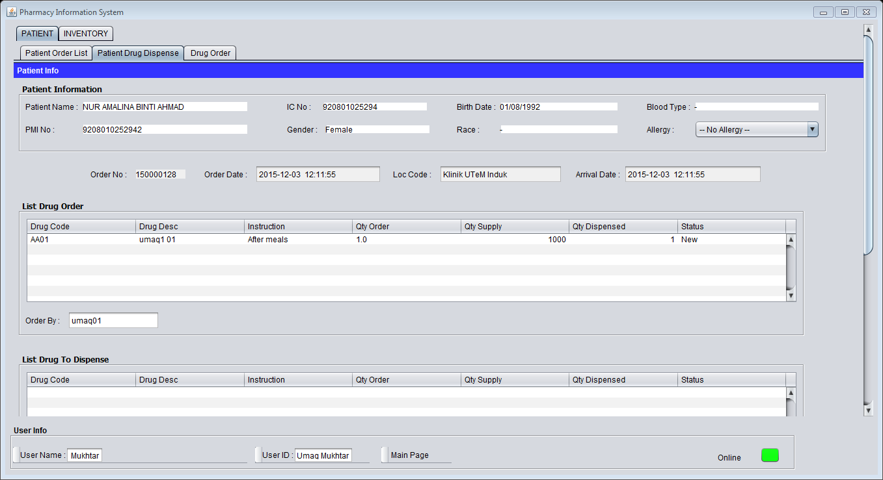

**6**

**5**

Figure 28

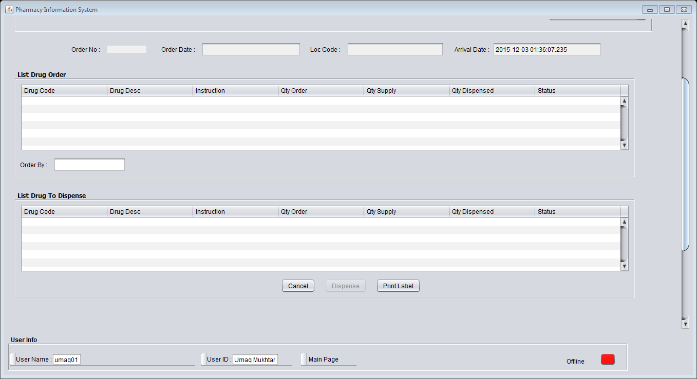

**7**

Figure 29

**Step 5:** Click “Patient Drug Dispense” menu bar.

**Step 6:** Double check the details.

**Step 7:** Click “Print Label” button to print the drug label. After that Click button “Dispense” to dispense the drug.

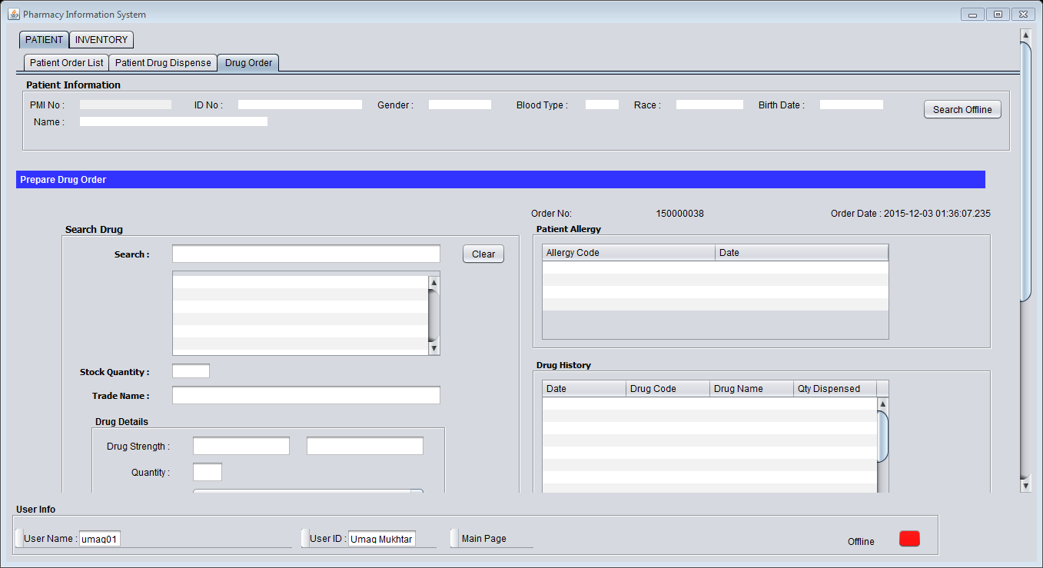

**12**

**9**

**8**

Figure 30

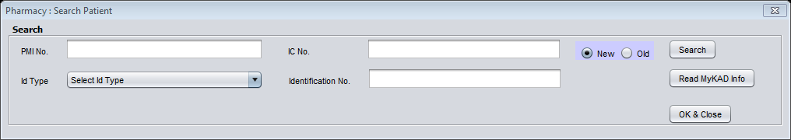

**10**

**11**

Figure 31

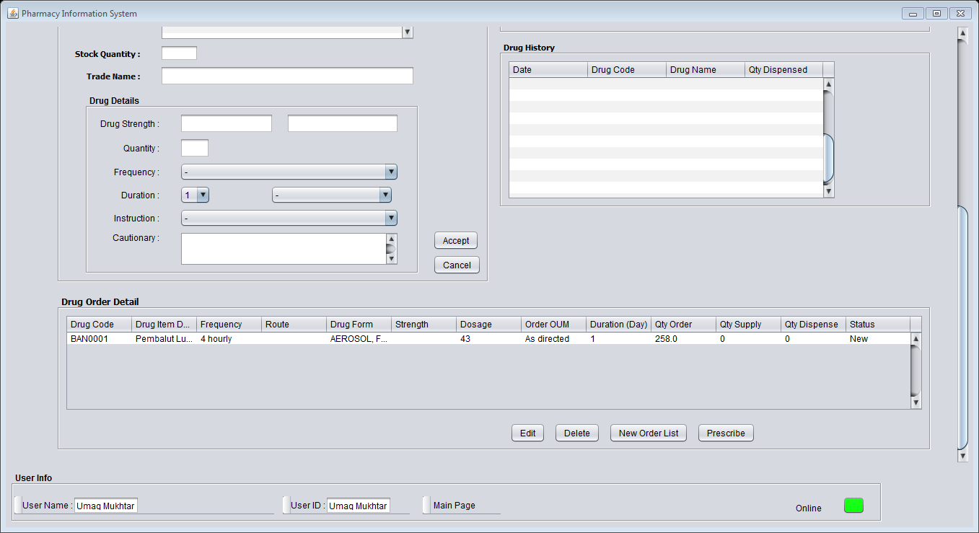

**12**

**13**

Figure 32

**Step 8:** Click “Drug Order” menu bar.

**Step 9:** Click “Search Offline” button.

**Step 10:** Fill the text field.

**Step 11:** Click “Search” button.

**Step 12**: Fill the text field. Then Click “Accept” button to save drug order details.

**Step 13:** Click “Prescribe” button.

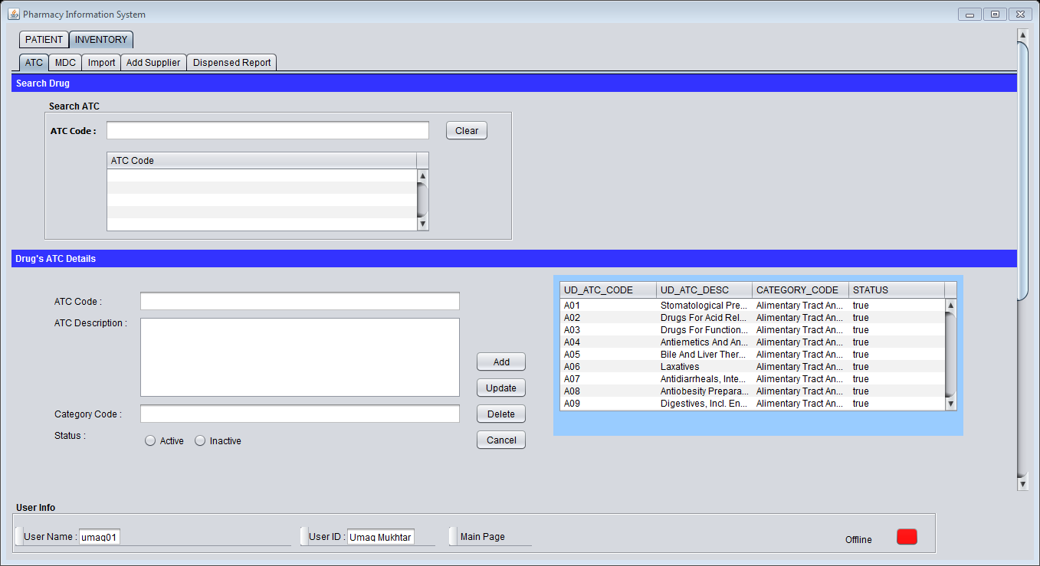

**19**

**18**

**17**

**16**

**15**

**14**

Figure 33

**Step 14:** Click “Inventory” menu bar.

**Step 15:** Click “ATC” menu bar.

**Step 16:** Browse the ATC Code.

**Step 17:** Fill the text field.

**Step 18**: Click “Add/Update/Delete” button.

**Step 19:** Browse the ATC Code.

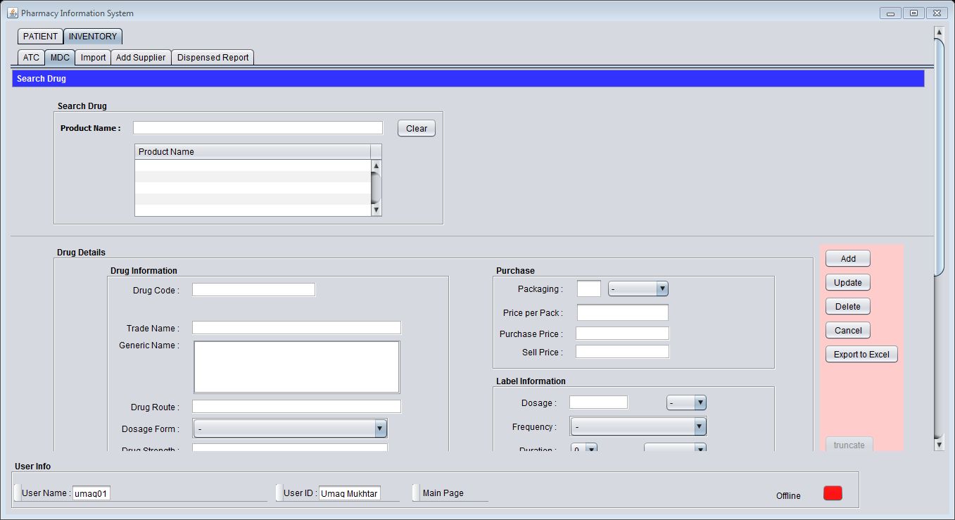

**24**

**22**

**21**

**23**

**20**

Figure 34

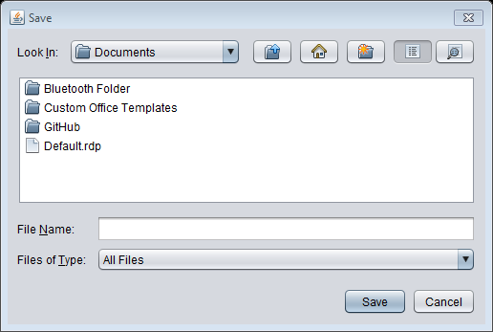

**25**

Figure 35

**Step 20:** Click “MDC” menu bar.

**Step 21:** Browse the Drug Name.

**Step 22:** Fill the text field.

**Step 23:** Click “Add/Update/Delete” button.

**Step 24**: Click “Export to Excel” button.

**Step 25:** set the location to save File and click “Save” button.

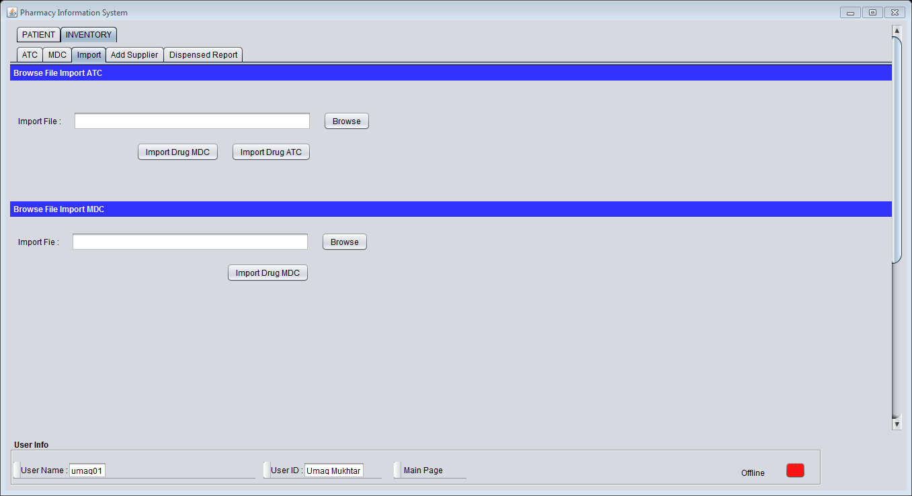

**27**

**26**

Figure 36

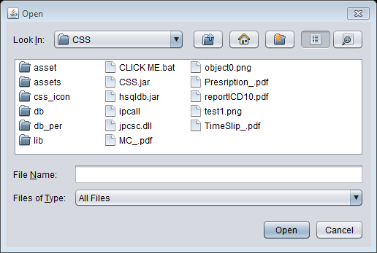

**28**

Figure 37

**Step 26:** Click “Import” menu bar.

**Step 27:** Browse the details.

**Step 28:** set the location to save File and click “Save” button.

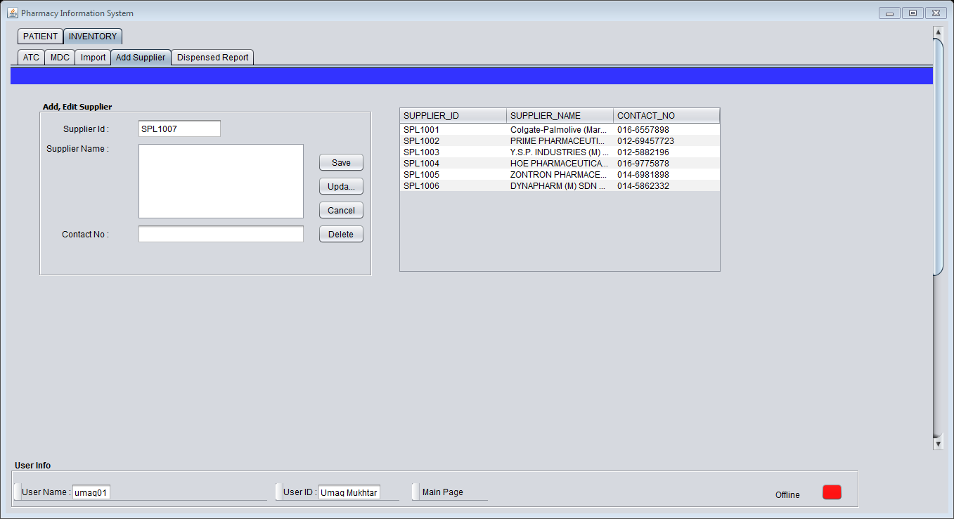

**31**

**30**

**29**

Figure 38

**Step 29:** Click “Add Supplier” menu bar.

**Step 30:** Fill the text field.

**Step 31:** Click “Add/Update/Delete” button.

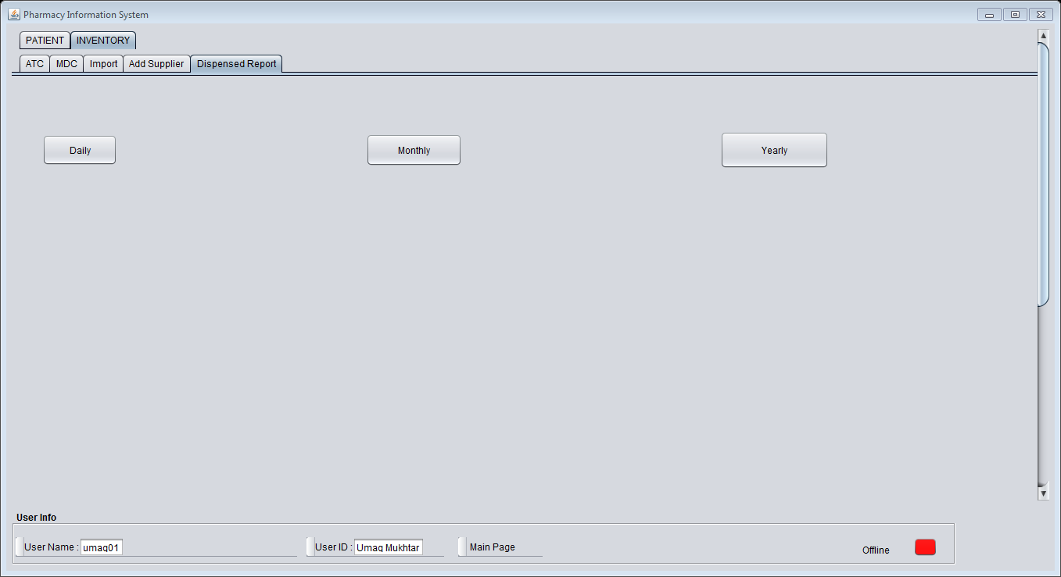

**33**

**32**

Figure 39

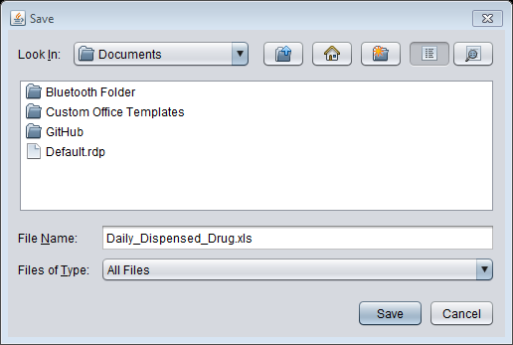

**34**

Figure 40

**Step 32:** Click “Dispense Report” menu bar.

**Step 33:** Click “Daily/ Monthly/ Yearly” button.

**Step 34:** set the location to save File and click “Save” button.